Generating overloaded/parameterized constructor

Right click in the class body -> Source -> Generate Constructor using Fields

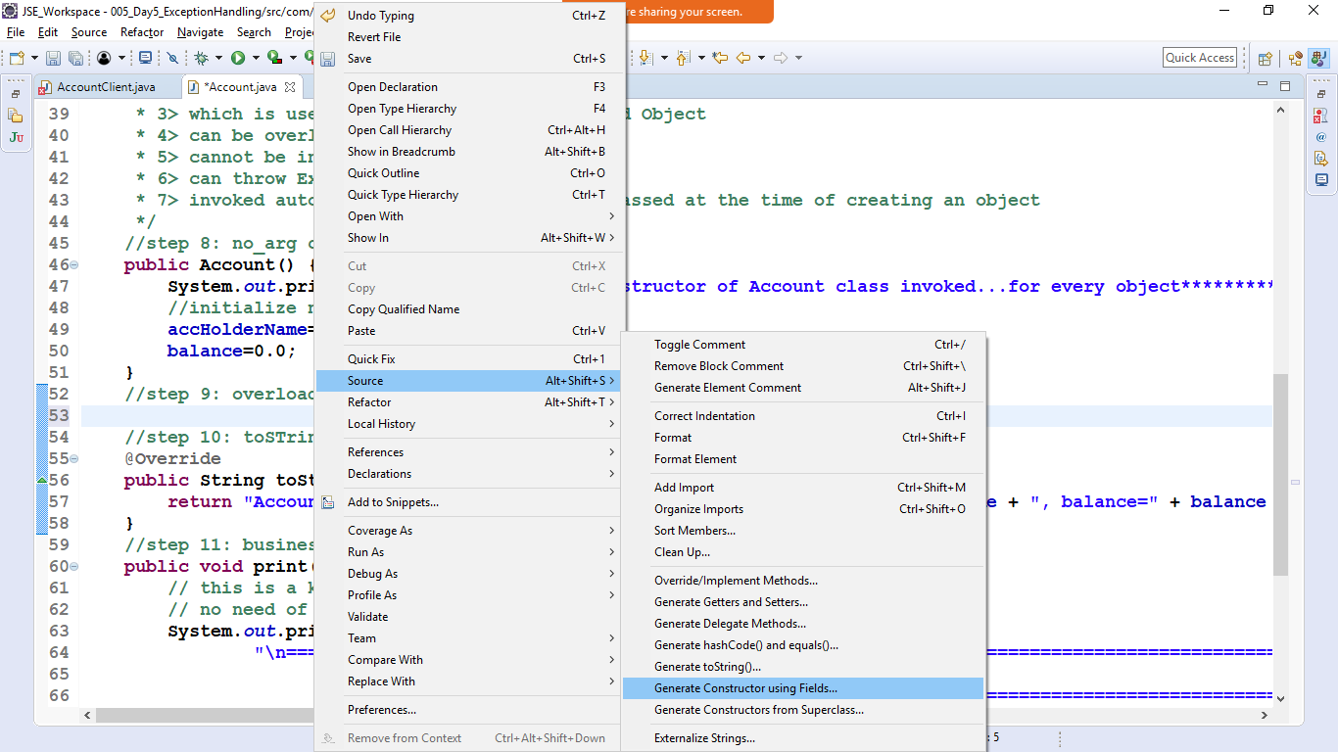

If id is auto generated then don’t check id

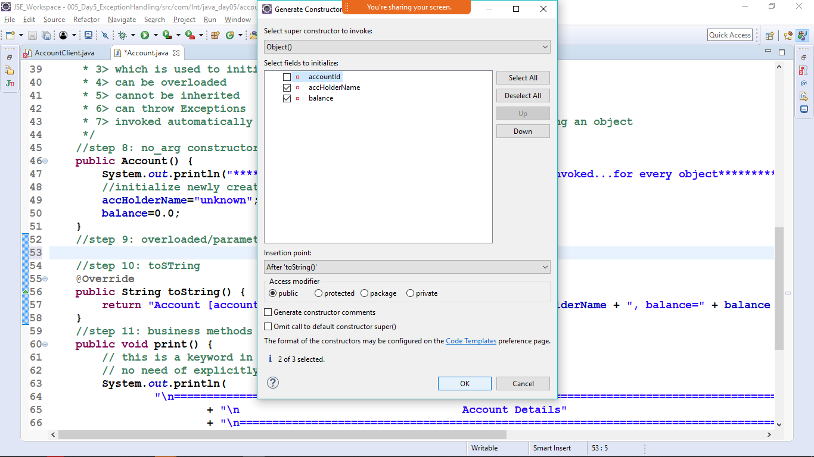

Which ever parameter need to be passed must be check and hot OK